**《Fundamentals of Electric Circuits》homework 5**

**6.13 Find the voltage across the capacitors in the circuit of Fig. 6.49 under dc conditions.** (10’)

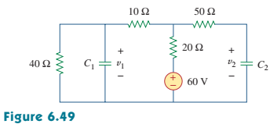

**6.19 Find the equivalent capacitance between terminals *a* and *b* in the circuit of Fig. 6.53. All capacitances are in *μF*.** (10’)

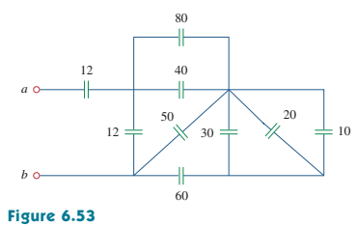

**6.22 Obtain the equivalent capacitance of the circuit in Fig. 6.56.** (10’)

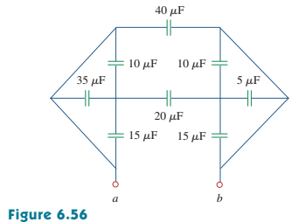

**6.32 In the circuit of Fig. 6.64, let *is = 50e- 2t**mA* and *v1(0) = 50V, v2(0) = 20V*. Determine: (a) *v1(t)*and *v2(t)*, (b) the energy in each capacitor at *t = 0.5s*.** (10’)

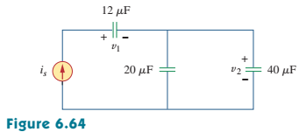

**6.55 Find *Leq* in each of the circuits in Fig. 6.77.** (10’)

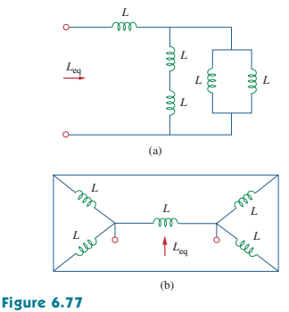

**6.60 In the circuit of Fig.6.82, *io(0) = 2 A*. Determine *io(t)* and *vo(t)* for *t > 0*.**(10’)

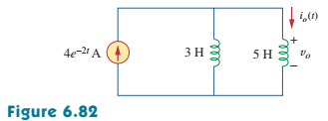

**6.65 The inductors in Fig. 6.87 are initially charged and are connected to the black box at *t = 0*. If *i1(0) = 4A*，*i2(0) = -2 A*, and *v(t) = 50e-200t mV*, *t ≥ 0*, find:**

**(a) the energy initially stored in each inductor,**

**(b) the total energy delivered to the black box from *t = 0* to *t = ∞*,**

**(c) *i1(t)* and *i2(t)*, *t ≥ 0*,**

**(d) *i(t)*, *t ≥ 0*.** (15’)

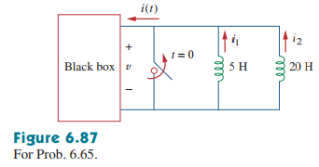

**6.72 At *t = 1.5 ms*,calculate *vo* due to the cascaded integrators in Fig. 6.89. Assume that the integrators are reset to 0 V at *t = 0*.** (15’)

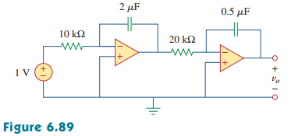

**6.74 The triangular waveform in Fig. 6.91(a) is applied to the input of the op amp differentiator in Fig. 6.91(b). Plot the output.** (10’)

